# **INTERPOLATION METHODS USING OPENCV**

**METHODS**

**1.INTER_AREA**

**2.INTER_NEAREST**

**3.INTER_LINEAR**

**4.INTER-LINEAR-EXACT**

**5.INTER_CUBIC**

**1.INTER_AREA**

INTER_AREA works better in image decimation and avoiding false inference patterns in images.



**ORIGINAL IMAGE**

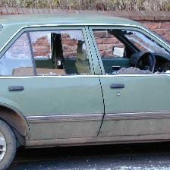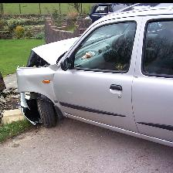

**RESULT**

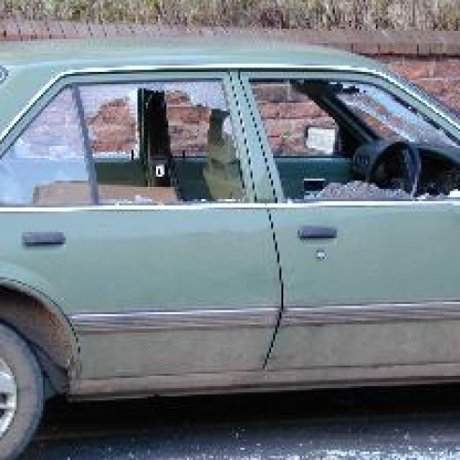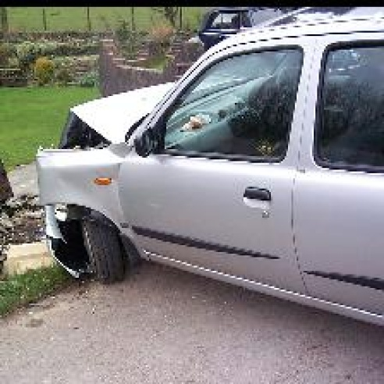



## **2. INTER_NEAREST**

Nearest neighbor interpolation algorithm. It retains the sharpness of the edges though the overall image may be blurred.



**RESULT**

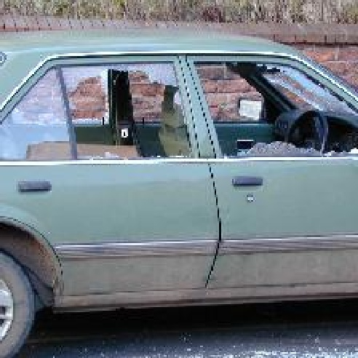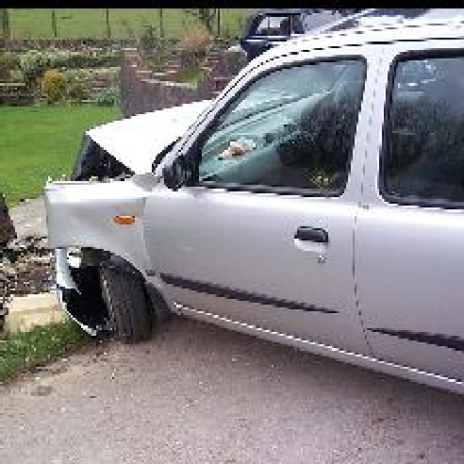



## **3. INTER_LINEAR**

INTER_NEAREST, this does the interpolation in two dimensions and predicts the function used to calculate the color of a pixel.

This algorithm is effective in handling visual distortions while zooming or enlarging an image.



**RESULT**

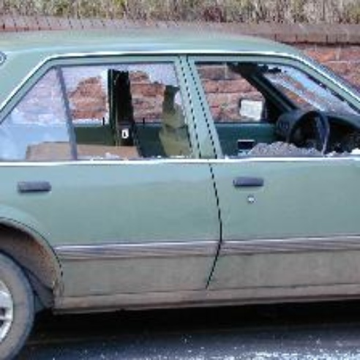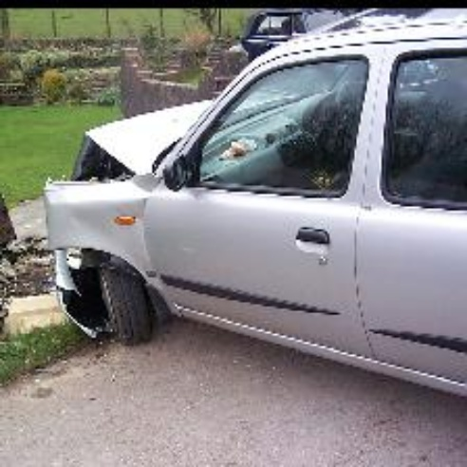



## **4. INTER_LINEAR_EXACT**

INTER_LINEAR_EXACT is a modification of INTER_LINEAR and both uses bilinear interpolation algorithm. The only difference is that the calculations in INTER_LINEAR_EXACT are accurate to a bit.



**RESULT**

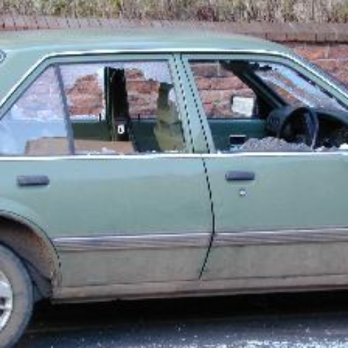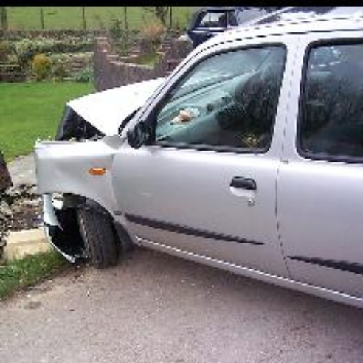



## **5. INTER_CUBIC**

This option uses bicubic interpolation technique. This is an extension of cubic interpolation technique and is used for 2 dimension regular grid patterns.



**RESULT –NOT GOOD**

**OTHER METHODS**

1. NTER_LANCZOS4
2. INTER_MAX
3. WARP_FILL_OUTLIERS
4. WARP_INVERSE_MAP

**CODE**

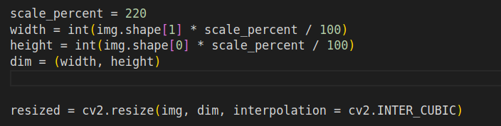

**SCALE PRECENTAGE 220**

**Tried with higher scale**

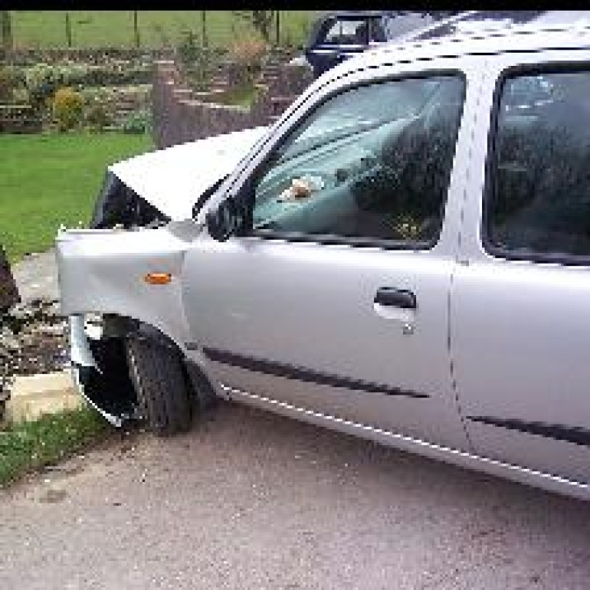

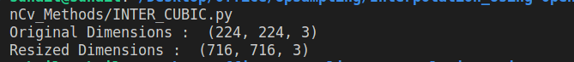

**DIRECT APPROCH BICUBIC INTERPOLATION**

**Result**

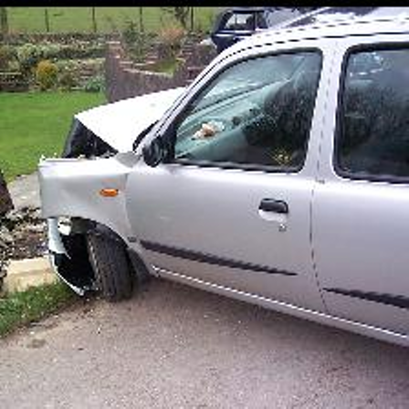

**Code**

